**PROGRAMS**

**Write a program to sum up all the elements of an array.**

**package** ArrayPackage;

**public** **class** ArraySumElements {

**public** **static** **void** main(String[] args) {

// **TODO** Auto-generated method stub

**int**[] numbers= {1,2,3,4,5};

**int** sum = 0;

**for**(**int** i=0;i<numbers.length;i++) {

sum += numbers[i];

}

System.***out***.println("Sum of the elements in the array: " + sum);

}

}

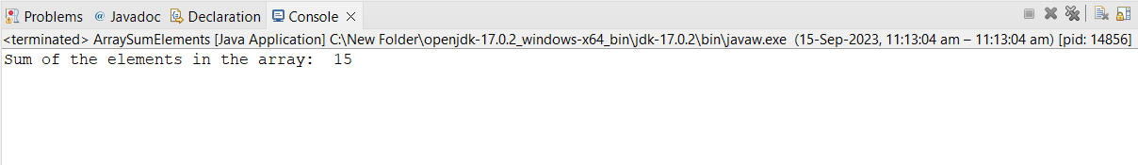

**Write a program to add two matrices.**

**package** ArrayPackage;

**public** **class** MatrixAddition {

**public** **static** **void** main(String[] args) {

// **TODO** Auto-generated method stub

//int a[][]={{1,3,4},{2,4,3},{3,4,5}};

//int b[][]={{1,3,4},{2,4,3},{1,2,4}};

**int**[][] a={{1,3,4},{2,4,3},{3,4,5}};

**int**[][] b={{1,3,4},{2,4,3},{1,2,4}};

**int** c[][]=**new** **int**[3][3];

**for**(**int** i=0;i<3;i++){

**for**(**int** j=0;j<3;j++){

c[i][j]=a[i][j]+b[i][j];

System.***out***.print(c[i][j]+" ");

}

System.***out***.println();

}

}

}

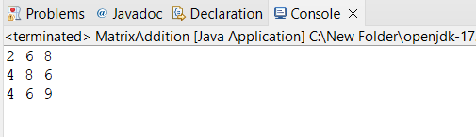

**Write a program to search array element with Linear Search.**

**package** ArrayPackage;

**import** java.util.Scanner;

**public** **class** LinearSearch {

**public** **static** **int** linearSearch(**int**[] arr, **int** target) {

**for** (**int** i = 0; i < arr.length; i++) {

**if** (arr[i] == target) {

**return** i; // Element found, return its index

}

}

**return** -1; // Element not found

}

**public** **static** **void** main(String[] args) {

// **TODO** Auto-generated method stub

Scanner sc = **new** Scanner(System.***in***);

// Input array

**int**[] arr = {10, 23, 5, 18, 4, 35, 12, 7};

System.***out***.print("Enter the element to search for: ");

**int** target = sc.nextInt();

**int** result = *linearSearch*(arr, target);

**if** (result != -1) {

System.***out***.println("Element found at index: " + result);

} **else** {

System.***out***.println("Element not found in the array.");

}

}

}

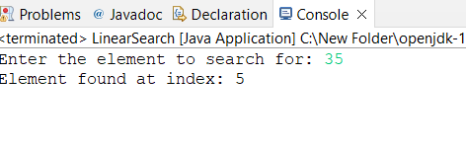

**Write a program to sort array element with Bubble Sort.**

**package** ArrayPackage;

**public** **class** BubbleSort {

**public** **static** **void** bubbleSort(**int**[] arr) {

**int** n = arr.length;

**boolean** swapped;

**for** (**int** i = 0; i < n - 1; i++) {

swapped = **false**;

**for** (**int** j = 0; j < n - i - 1; j++) {

**if** (arr[j] > arr[j + 1]) {

// Swap arr[j] and arr[j + 1]

**int** temp = arr[j];

arr[j] = arr[j + 1];

arr[j + 1] = temp;

swapped = **true**;

}

}

// If no two elements were swapped in the inner loop, the array is already sorted.

**if** (!swapped) {

**break**;

}

}

}

**public** **static** **void** main(String[] args) {

// **TODO** Auto-generated method stub

**int**[] arr = {64, 34, 25, 12, 22, 11, 90};

System.***out***.println("Original array:");

*printArray*(arr);

*bubbleSort*(arr);

System.***out***.println("Sorted array:");

*printArray*(arr);

}

**public** **static** **void** printArray(**int**[] arr) {

**for** (**int** num : arr) {

System.***out***.print(num + " ");

}

System.***out***.println();

}

}

